HEBET EN BA:
The Egyptian Mystical Rites
Alexander the Great was 'converted' by it.. and spent the rest of his short but eventful life trying to fit his Macedonian heritage into Egypt's magical power. Julius Cesear was won-over not only by Cleopatra but the Egypt over which she was Queen.. as was Marc Anthony, after him. Napoleon was mesmerized by it; and ordered his army to survey and catalog all of the ancient wonders they found in Egypt's mysterious sands. From Rome to Paris, London and Washington DC Egyptian obelisks have been raised over the great cities of the world, in mute testimony to the magical spell of Egypt.
I was 'spell-bound' by it too, from the time I first saw pictures of the ancient relics of Egypt in my school-books. I could not explain why, but something 'different' happened to me when I looked at those pictures.. something that never happened at all when I was not looking upon the Magic of Egypt. It is an Enigma, like the Sphinx which is it's most famous symbol. Any who have been touched by it's spell can neither "explain" it nor solve it's riddle.
But we CAN surrender to it, if we wish. For generations now the ancient texts have been available to us, to study; Hebet En Ba: the Book Of Rites. It was left for us, carved and painted upon tomb-walls, written on papyrus scrolls buried with scribes, viziers and kings. Sure, you have to be able to 'weed-out' of the scrolls the lengthy Funerary Prayers (for the great Rites were preserved, intermingled with the Funeral Rites as well).. but that is not difficult to do. For any who really want them, the Rites Of Egypt are there for us to find and use.
I discovered Hebet En Ba in my teens.. over thirty years ago, now.. quite 'by accident.' Having saved-up for a copy of "The Egyptian Book Of The Dead" translated by E. A. Wallis Budge, I discovered the joy of reciting it's ancient lines aloud to myself. I thought at first I was only being "picky" and squeamish for never reading-aloud the Funerary bits; as I thought I was only taking Poetic License when I carefully pieced-together phrases from one Chapter to combine with phrases from other Chapters, to produce what I found "more meaningful" than the arrangements found in the Funerary Texts. But, after a short while I realized that what I was reciting aloud in the ancient Egyptian tongue was actually happening to me, afterwards.
I am no 'authority' on what is possible for other people. The Rites I have used have helped me, and I am eternally grateful to them. They have also helped many others who "borrowed" or discovered them through me. Perhaps they will also help you, if you wish. The "scroll" of Rites which you will reach in a moment or two is yours to grow by. I wish you joy of it.
Notes On Ceremonial Mysticism
That ancient Egyptian Mysticism relied upon the same "Tetramorphic" magic circle familiar to all other Mysticisms the world over is beyond argument. While no actual 'Ritual Instructions' used by the Temple Authorities have survived the centuries, we certainly do know that the Egyptians recognized four "deities" or Neteru (the Egyptian word for "Spiritual Powers" within Nature, commonly translated as 'gods') who governed the Four Quarters of the globe. These are named Tuameutev, Amset, Qebsenuv and Hapi.. and are assigned specific directions of the compass, each. Thus, it can be reasonably implied that these Neteru or "Natures" were addressed in the same way by Egyptians as they are (under different names) by European Pagans, Native Americans and Hebraic Kaballists.
Being practicing Kaballists with more than a little exposure to Native American traditions as well as European Paganism, we in our Order simply perform a Circle Rite; standing in the center of any place we wish to use as our "sanctuary" we hold out our right hand to the EAST while saying in Egyptian 'homage to thee, Tuameutev' (Anet-hra.k Tuameutev) then turning SOUTH we name the Power Amset then turning WEST we name Qebsenuv and turning NORTH we name Hapi. Turning back to the EAST (where the Sun and therefore Life 'rises' upon the earth) we name lastly one of the three "Cradle Deities" who caretake the inception of New Life and Beginnings within Egyptian Mystical tradition. Named Shai, Renenet and Meskhenet, these three each caretake one specific type of New Beginning.. and which one you address ought to fit the type of Rite you are performing.
SHAI: the Power of FORTUNE
If the end-goal of one's Rite happens to be "Good Fortune" in the material, wealth, health and happiness departments, then the traditional custodian of that is named Shai. This Neter is considered the custodian of all material bounty, and is the natural choice in many life-circumstances.
RENENET: the Power of LUCK
If the situation one's Rite is intended to improve happens to be that mysterious stuff variously called 'Destiny' and 'Luck' as well as "Favorable Outcomes" in one's affairs, then the natural choice is Renenet, the Neter of "happy destiny and good luck."
MESKHENET: the Power of NEW LIFE
We all need a New Life occasionally; whether it is new vitality for our bodies or a new Life-Direction for our future, or a "rebirth" for our society or those within it. In all such cases, the natural choice of 'patron' for one's Rite would be the "birth-diety" Meshkenet, who presided over the birth-bed of the ancient Egyptians. As the patroness of Midwives, Meskhenet is also invoked by all those who attend the rebirthing of others.. from healers of the body, mind and spirit to guides of the Soul or even of the professional career.
Thus, a Ritual Circle might begin and end facing East, invoking "Anet-hra.k Tuametuev, Amset, Qebsenuv, Hapi, Meskhenet (or Shai or Renenet;) Ankh.v em T'etta.a!" (live or behave according to my words.) This might then be followed by any Rite taken directly from the Hebet En Ba that follows, or composed by you specifically for your needs.
But, Why In EGYPTIAN?!
I cannot 'prove' that such things make any difference at all.. except by quoting examples of success and it's absence. According to the Egyptians themselves, their language was given them directly from the Spiritual World, by the Neteru or "gods." Certainly ancient Egyptian has similarities and common roots shared with some other ancient languages, though Egypt's claim that the very sounds comprising their language are themselves "Powers" should not be dismissed lightly (future generations of scientists may yet discover that Sounds are Powers in their own right.) But perhaps the best argument in favor of the use of "reconstructed" Egyptian in these Rites is that Egyptian "divinity" may very well still 'speak' the Egyptian tongue. Silly as this may sound to you right now, you may change that opinion, should you happen to meet one of the Neteru as a result of these Rites. Be that as it may, these are the Egyptian Mystical Rites we have used, and found to be worthy.

PLEASE NOTE: you would be well-advised to carefully study the Adendum at the end of the following Scroll, before you improvise any new Rites of your own.. especially any including the names of other Egyptian "deities;" for some of those Neteru are simply not "safe" or wise to invoke.

HEBET EN BA: THE BOOK OF RITES
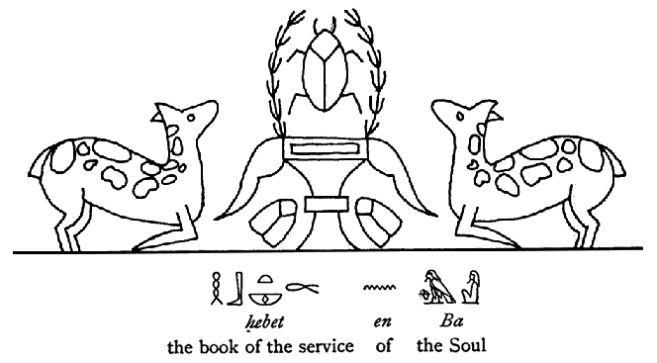
Invocation of the Godself
We all "sense" the presence of Amen, the Hidden One living within us.. and all spiritual Paths attempt to connect us consciously with "him" (or "her" or "it!.") This invocation informs Amen that you "know" of him and wish to integrate him fully. Used however often one wishes for an initial period of "Introduction" to the Godself Within, this Invocation may stimulate Amen's "revelation" of himself to you while also establishing the "dialogue-circuit" of "logoic speech" in Egyptian between you and your Indwelling Godself, Amen.
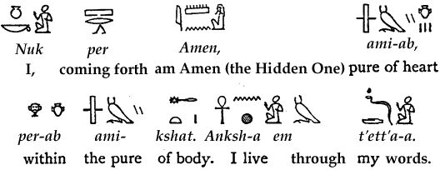

Invocation: Overcoming Karma
Once one has had an introduction to the Godself Within and begun working on integrating that fully as a lifestyle, the next major step one usually takes is "cleaning-up one's life." Karma.. or the consequences of previous unconscious (human) living.. gets removed by EFFORT and SELF-DISCOVERY. During this Karma-Cleaning phase one discovers The Tree Of Life where we meet "the Throne" or Pillar Of Heaven.. the spiritual hierarchy of "the gods." All of this is stimulated by the following Rite.


Invocation of Soul Memory
We may have a lot more Karma than we realize!.. some of which may be surviving bits of "past lives." Do you think you may have lived before as a human being?, or in a non-incarnate Spirit-form before your human birth(s)? This Rite is designed to "surface" those and put you in touch with the other self-fragments hidden in your psyche. The Three Paths spoken of are called by Kaballists "the Hermetic, the Orphic and the Mystical Paths;" and the Two Pillars mentioned here are Aima/Anima the Black (feminine) Pillar of Psyche and it's White Twin, Abba/Animus the masculine side of Self. All of these things this Rite gives you entry to.. as you explore the Akashic Records of soul memory within you.
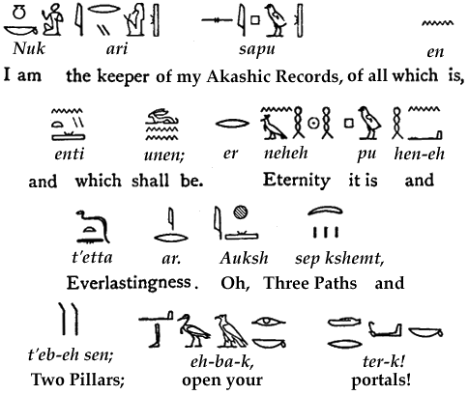

Invocation of Astral Flight
We live (according to the Egyptians) on no less than NINE other "dimensions;" including many which are so non-physical that we can only "dream" them.. yet they remain very important parts of our lives. This Rite can stimulate the awakening of the "dreamer" within the Astral and Causal Planes or dimensions. Used before sleep at night, it can trigger vivid dream-life recall and the ability to direct your dreams consciously.
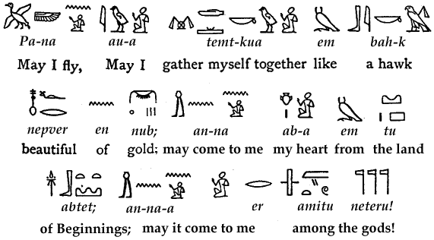

Rite Of Initiatory Blessing
How to help others realize their potential and begin growing mystically is a frequently-asked question for those on the Path. This Rite may be spoken over another person (addressing it to them by name, upon starting) to remind their soul of who they are and encourage self-integration. In truth, that is all we can really do for anyone else! Most of the powers of Spirit are "self-help" only.
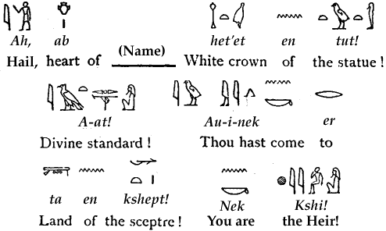

Rite Of "Hieros Gamos"
Meaning Sacred Wedding in Greek, the Hieros Gamos is the unification of the two "sides" of self; the Conscious Lover and it's Unconscious ("Still-Hearted") Beloved. Performing this Rite may stimulate the integration of these two sides of Self, and end the separation between who you are while awake and who you become when dreaming. It also draws your personal Neter-Archetype (or God-Aspect) to you, in a truly Sacred Marriage between Creator and Creation. Once you have clearly glimpsed your Totemic Identity or Nature, you may want to strengthen your integration of that by performing the Rite of Totem-Integration listed in the Addendum toward the end of this page..
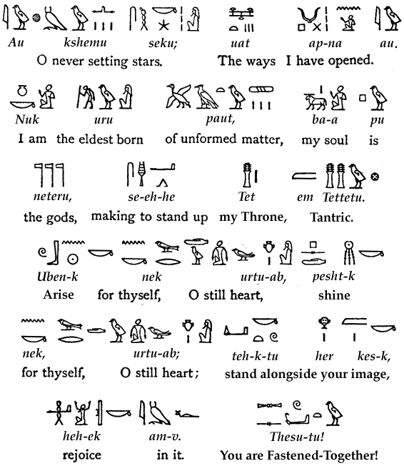

Invocation of Divine Identity
We do not have to wait until we "die" to become a "divine" or Spiritual Being. This Rite actually "completes" the Rite of Amen, listed earlier; it identified you as (really) Amen; this one identifies Amen as REALLY you. The difference may not be apparent logically right now, but it may become clear after this Rite has worked it's way on you..
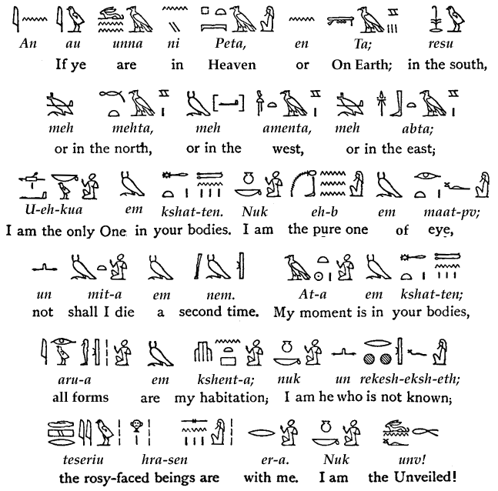

Invocation of The Divine Beloved
This Rite follows-up on the Hieros Gamos listed earlier.. which unified you with your inner God-Aspect or Neter-nature. Now, how to love, permanently within that Divine Marriage: this Rite activates the Moon-Mirror (called "Shaddai El Chaiim" in Hebraic Kaballah) to bring God as your "spouse" to you in the Neter-form you were created to share that "tantric partnership" with, and consummate your union, as a Lover. When you call down the Moon, be ready for it's power!.. for the Beloved is very mighty, and will never release you from their embrace!
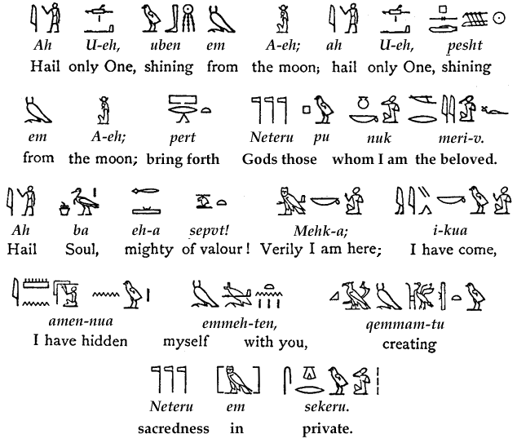

Rite Of Healing
This Rite may be performed for oneself or others, to help restore the natural youthful health of the body, mind and soul after injury, illness or trauma. Because this Rite implies that one is a "guardian of the Self-Cackling Egg" (or Original Creator,) it will have little effect unless spoken by one who has integrated the Invocation of Divine Identity listed above..
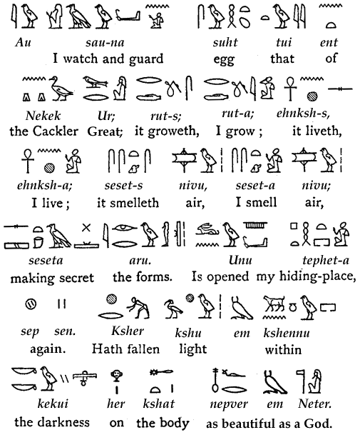
ADDENDUM: The Gods Of Individuality
At the very heart of Egyptian Mysticism is a system of 'thought' and experience so primitive or primal in nature that it is virtually forgotten by the so-called 'civilized' peoples of the modern world.. TOTEMISM.
While often derided by 'science' as superstitious nonsense, Totemism is so universal a part of our species' oldest spiritualities as to deserve a closer look. After all, why would literally all ancient peoples have 'believed-in' something that is completely without value?!
The Neteru or "gods" of Egypt were (and still are!,) composite creatures made up of one specific Animal Totem merged with a human being.. implying not only that our "gods" but we ourselves are "composite creatures" containing living elements of Nature embedded within our Psyches or Souls. Modern religions have tried very hard to deny or negate the value of this primal layer of Animistic or Totemic Nature-Spirits within us.. though the basic facts of our Natures ("Neteru" in Egyptian) has not changed one bit through all that religious propaganda. We are and apparently will always remain LIVING TOTEMS as seemingly 'grotesque' or, (if you share my appreciation for the beauty they really have) at least as organic as the "gods" of the civilization of the Nile. It is the Experience of the thousands of Egyptian Rite Mystics the world over that the Neteru of Egypt ARE the actual "Archetypes" of which we are spiritually composed.
Egyptian Rite Mysticism is the process of discovering one's own personal Totems and invoking their assistance as well as the assistance of any of the other Neteru whose good services you might need at any given moment. In the listing that follows, look for yourself, symbolized as well as the many good friends you may wish to call upon from time to time.
The Totemic "Natures" Of Human Life
"Heru:" the Falcon of Spiritual Victory
Recognized by theologians as the "prototype" or original upon which all later "Saviors" have been fashioned, Heru (or "Horus" as the Greeks pronounced his name) was the Neteru who finally vanquished Set after that enemy slew Heru's father Ausar.. after which Heru/Horus became the "god" of the Sunlit world of the LIVING while his father Osirus became the Lord of the Afterlife. Those of Horus' totem are thus successful activists, driven by an inner sense of DUTY to correct the social abuses left over from past ages. The Coptic (Egyptian) Christians applied the name "Heru" to the Christ-consciousness.. and that may very well be it's best description. Actual MEMBERSHIP in this Totemic Lineage is PROVEN only by dreams and other Mystical Visions, showing oneself to actually BE a Falcon.
"Het-Heru:" The Cow Goddess Of Spiritual Blessing
Meaning "the House of The Lord," Het-Heru (or "Hathor" as the Greeks pronounced it) is the symbol of MOTHER NATURE as the "house" in which we live.. in other words, the World around us. She was invoked for every form of blessings that Mother Nature can give; Life, Health, Strength, Fertility, Wealth and the Joy of Life. Adored at many Temples in Egypt including Medenet-Habu in the Sinai (where Moses and the Israelites stopped on their journey briefly) Hathor survives in Hebrew tradition as "the golden calf" of Exodus. Those born of her Totemic Lineage are deeply devotion-oriented and prone to lives of BLESSING OTHERS rather than self-service. From Education of the young to Healing the body, mind and soul, Het-Heru can be found wherever JOY is being celebrated as a Blessing.
"Anpu:" the Jackel of Soul-Guidance
Called Anubis by the Greeks, Anpu is the black dog-like creature who tags-along beside the Soul on it's endless journey through life; and naturally symbolizes everything we today associate with the dog as "Man's Best Friend." Anpu/Anubis is the Totem of the "guru" or Soul-Guide.. who helps the Soul "sniff-out" the safe Path to travel upon. Those born of this wise, loving and deeply loyal Totem are life's natural-born counselors, therapists and Spiritual Examples.. who embody the principle of FRIENDSHIP and a spirit of helpfulness for all those they meet.
"Apis:" the Bull of Fertility
"Apis" or "Serapis" as he was also called, was the Totem of FATHERHOOD. Bulls have been revered as symbolic of the power to sire children throughout history, as well as being the symbol of security, wealth and temporal power ("as strong as a Bull" remains a part of our language even today.) Because of these facts, Apis/Serapis held a special place in Egyptian culture, as one of the official Totems of the Pharaohs; for Apis symbolized all of the power, wealth, security and ability to Father successors that a Pharaoh was expected to "live up to." Those born of this Totem-Lineage have a deep affinity for the Bull and all things "Taurean" and are often connected with either food-service, farming, engineering or building trades. In all cases, the Bull features prominently in their dreams and soul-visionary experiences.
"Tehuti:" the Ibis-headed Record-Keeper
Called Thoth (pronounced exactly like the English word "thought" which it in fact means) by the Greeks and associated by them with their own diety Hermes (the Latin Mercury,) this Neter was in fact named "Tehuti" in Egyptian. Just as we in more recent times have called writing "chicken-tracks" (especially if written by a beginner,) the ancient Egyptians associated reading and writing with the tracks left on the beach sands by the Ibis.. a large and graceful bird similar to a stork or crane. That Tehuti should become known as the patron-Totem of Scribes, Teachers, Scientists and Messengers should be no surprise, therefore.. though some moderns have mistakenly associated him also with an "intellectualism" which he did not have anciently. Rather, Tehuti was simply the Totem of WRITING THINGS DOWN and then READING THEM ACCURATELY, AFTER. Those born of this Totem-lineage are thus note-takers, scribblers, archivists, librarians and "by-the-book" copyists. Those who dream Thoth-dreams are nonetheless blessed with KNOWLEDGE to caretake.. once they learn to simply WRITE IT ALL DOWN!
"Amun:" the Goat Of Everlasting Creativity
No Neter or "god" of the Egyptians has left so indelible a stamp upon the world as this First Father of the Gods. Variously also spelled Ammon, Amon and Amen which means "THE ONE HIDDEN WITHIN," Amen's spell is so mighty that over twenty centuries after his last Sanctuary was abandoned to the desert sands, every Judeo-Christian prayer that is uttered still whispers his name in closing! Originally a great, horned (and horny!,) black MALE GOAT, Amen/Amun is the Totemic symbol of THE POWERS OF MAGIC OR MIRACULOUS SOLUTIONS THAT LIFE NEEDS at any given moment. It is a well-known fact that Amun created the universe through masturbation.. he HAD TO really, for he existed before any "mate" existed for him to mate with. Amen masturbated and drank his own seed from one hand.. and spat-forth the Stars (the goddess "Nut" listed below,) and then (taking the shape of the god "Nu,") he mated with her to beget all the Neteru in the Egyptian Pantheon or "Great Company of the Gods." Those born of the Totem of the Goat are thus profoundly connected to sexuality in all it's forms, and creating ORDER out of Chaos, by begetting "solutions" out of "thin air." All those who share his Lineage also share in his power to materialize whatever is needed in order to make Life HAPPEN. They are all living Magi, with the power and the wisdom to Create BY (sexual) MAGIC.
"Nut:" the Sky-Goddess
There are only a few Neteru whose Totemic symbol is not a bird or animal, and Nut is one of them. As the personification of THE SKY her symbols are the Stars at night and the "Blue River Of Heaven" by day (for the Egyptians as well as early Semites called the sky "the stream above the firmament of Heaven.") Being the first-created "god" or Lifeform, Nut is the original Soul-Mate of the Creator, and as Great Mother she embodies everything we revere about Motherhood itself; she represents loyalty, fidelity to those she loves, and the good cultural example which a mother sets for her house.
"Geb:" the Earth-God
The goose was long-ago selected by Egyptians as the symbol of the good husband because the goose is a monogamous bird which breeds for life (a 'widowed goose' who has lost it's spouse may live the rest of it's long life alone, out of loyalty to their Beloved.) The Neter of the good husband, consort and loyal father is thus Geb, the Goose-Totem. Look for Geb wherever lifelong loyalty to the family is being celebrated; somewhere nearby you will find the Goose! Geb is also depicted as a soil-colored man lying wrapt around the earth, with his erect penis aimed upward to the Sky where Nut his Beloved wife bends down to unite with him. Geb (often also spelled Seb or Qeb) is invoked for sexual compatibility as well as fertility.
"Ptah:" the Great Designer
Another of the "gods" of Egypt more associated with symbols other than an animal is Ptah who represents God as "the Great Designer and Builder of the Universe." Ptah's major symbols are the Masonic Square and Compass, encircled by a knotted length of rope. Rope was a familiar symbol in Egypt, representing the ability to move large or heavy objects through the labor of many men (much as the Pyramids convey to our minds today;) and all those born of Ptah's Totem are organizers of men, envisioners of great designs and the building of durable monuments of industry and value. Ptah is the patron of modern Freemasonry.
"Bastet:" the Maternal Instincts of the Cat
"Bastet" or Bast as she is sometimes called is the Totem of the Cat and represents all of the playful, purring, devoted CARE AND NURTURE which the female housecat lavishes upon her young. We all at times want "fussed-over" and comforted by some strong, serene and completely competent Care-giver.. and it is precisely at such moments that we meet the Totem of the Cat. Bastet is the patroness of childhood, child-rearing, education and "baby-setting services" such as nursing. As well-known anciently as it is today is the Cat's constant mental "prowling" for something fun to do; and Bastet's Totem Members are likewise always out looking for someone's tail to pull, a ball to chase or some other Game to play with other young-spirited "cats" and "kittens."
"Ksheper:" the Scarab-Beetle of Immortality
Perhaps the most familiar Neter to many modern westerners is "Scarabaeus" the Dung Beetle. Sometimes also spelled "Xeper," this Neter depicts God rolling the world around the heavens, while hatching-out his young in it's soil.. the literal fact of how the Scarabaeus Beetle reproduces itself. As a Totem, Ksheper denotes creativity and the caretaking of one's creations from beginning to end. Those born of the Scarab Totem are inventors, engineers, architects, builders, creative writers and all others who "carry the ball" for society's PROGRESS. Look for this Lineage wherever eternity is being served; for this Totem builds with eternity in mind (ancient Egyptians strewed the path of funeral processions with images of the Scarab, to make eternal the Path of the departed soul.)
"Nephthys:" the Altar Of Mercy
That "holy Spirit" or "holy ghost" familiar to modern Christians as the symbol of Providence, Miraculous Help and Divine Intercession in our behalf was also known to ancient Egypt, where it was called "Nephthys" the House Of Prayers-Answered. Nephthys was symbolized not by an animal but a picture of a Temple shaped like an altar-stone with a door leading into it; thus she represents "the Spirit dwelling within the Altar".. or the holy spirit who answers prayers and provides for our needs. Those born of this deeply humble, devoted and sincere Totem-Lineage are the Temple servants, monks, nuns and ministers of mercy who caretake our species' spiritual needs. Whether found in a Temple hearing confessions and blessing the ill, or in the kitchen cooking dinner for their children, those of Nephthys' "kind" can be known by the aura of mercy which they exude like incense into the air. Nephthys is the personification of feminine compassion, as her brother Ra is of male victory.. and all those who serve her Altar of Mercy (in any culture or period of history) wear her "dress:" the Robe of Sacred Service to inform the world that here is Her Mercy Enshrouded.
"Hu" and "Saa" and the Ship of the Soul
While little understood even by such Egyptologists as Budge, there are two Neteru whose lineages are necessary for us all to keep in mind. Hu is the Steersman or Pilot of the Ship of Ra (listed below;) and his brother Saa is his Navigator who plots the course for the Ship of the Soul. Those born of these Totemic Lineages may recognize themselves mostly from their innate tendency to "pilot" or "navigate" themselves and others through life's "rough waters." The natural-born Strategists and "Movers And Shakers" of society, these Lineages are called-upon by any who need help knowing where they are going and actually getting there.
"Ra:" the Eagle Of The Sun
Lastly we will list that most ever-present Neter so important to Egyptians that virtually all their "good gods" were considered a "form" of him: RA, the Sun God. Also sometimes spelled "Re" but always depicted as either the disk of the Sun or an Eagle-winged or Hawk-headed great Bird of Heaven, Ra originally simply denoted masculinity itself; the Power of a Man over the world he must govern. Like the Eagle to all other cultures that know of it, Ra is the embodiment of the victory of Light over all Shadows, and perhaps the best title by which to describe him is simply LORD OF LIGHT. Look for this Lineage in the military, police, fire brigades, government offices and all other places where men overcome danger through courage.
And there are MANY, MANY more!..
For a full description of all the other Neteru of Egyptian Mysticism, see the excellent two-volume set of books The Gods Of The Egyptians, by E. A. Wallis Budge. Any Egyptian Rite aspirant should own a complete set of them, plus a copy of Budge's other masterpiece, The Egyptian Book Of The Dead.

Rite Of Totem-Integration
Once you have actually located your personal Totemic Nature from the list above (or other researches into the "gods" of Egypt,) you may wish to actually become that "full-time" rather than experiencing it only during short moments such as during dreams and meditations. That Totem-Integration can be stimulated by the Rite which follows, which is addressed to the goddess "Nut" and her Four-Horned "spouse" the Bull Of Eternity (symbolic of the Four "Worlds" in which we dwell.) Please note that this Rite requires you to insert your own personal name at birth, in several places, plus the name of the Neter or Archetypal Totem which you have found yourself to be.. for example, "Heru" or "Het-Heru" or "Anpu."
Once actually affecting you, this Rite should help your Totemic Spirit Nature to emerge quite fully into your daily life as well as your dreams and other inner states...
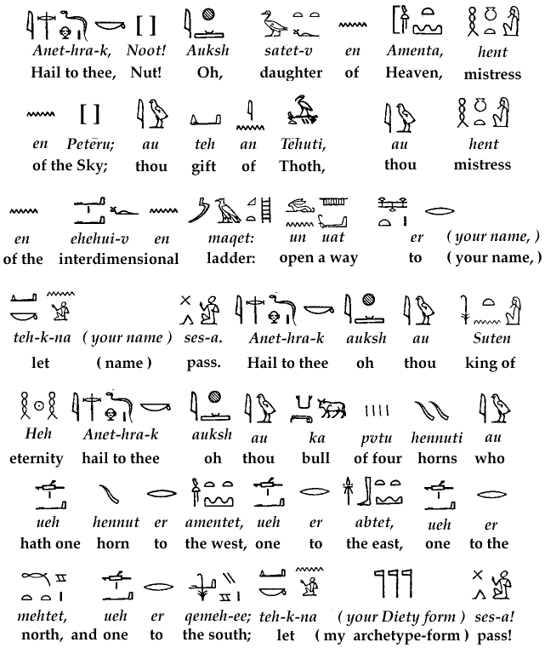

THE "GODS" OF DESTRUCTION
Not all of the Neteru participate in healthy human society, however.. for some of them are "gods of destruction" that participate only in the psychology of criminal and 'twisted' minds. Unless you KNOW FOR A FACT that you are part of their "lineage" and need to "fix yourself," you are well-advised to NEVER INVOKE "SET" (Sutek) OR ANY OF THE OTHER NETERU OF DESTRUCTION! Why? Simply because, like any of the other Neteru they WILL come, when called.

THE "GODS" OF DEATH AND THE AFTER-LIFE
Many who first discover the spirit of Egypt are led (by the sheer frequency with which they are mentioned) to include the famous "Osirians" in their Rites. Experience teaches that this is a capital mistake! The Neteru named Ausar but more commonly conventionalized as "Osirus" is the "god" of the Afterlife and none of the living have any reason to invoke him. The Osirian Rites ("Hebet Em Ka") which comprise so much of The Egyptian Book Of The Dead are the FUNERARY RITES of Egypt, and are rightly to be used only by Undertakers and those presiding over funerals. Any invoking of Ausar/Osirus eventually leads to an "ending" and a journey away from Life into the Afterlife. The few on earth whose right livelihood is that of Funeral Director and Minister of the Last Rites may safely use the Osirian Rites of Passage.. but even for them it is fraught with dangers.
Isis or as it was originally pronounced in Egyptian, Auset, was the wife of Ausar/Osirus.. and it was she who actually prepared the body of Osirus for it's journey to the Afterlife. Consequently.. even though she was viewed by Egyptians as the Neteru of magical powers, those were the powers of the AFTERLIFE only. Isis is rightly to be viewed as the original "type" of Mut the Vulture Goddess, depicting the Great Mother as custodian of the Funerary Temple. Any invoking of Isis or Mut involves one with funerals and the survival of the Soul after death.
The "gods" and "godesses" of spiritual "punishment" and "purification" are likewise very dangerous to invoke, and should not be called upon for the same reasons given for Isis, Osirus and Set (the "Osirians.") These "hell-custodians" include Sebak and dozens of lesser "demons" whose job it is to literally frighten the Hell out of the newly-deceased. The Crocodile-goddess and all the other "hell-fire totems" are important teachings for us all to learn from.. but what we should learn is to AVOID THEM ALL, AT ALL COSTS!
The "Paths Of the Dead"
Likewise to be avoided by most of the Living are those "Nether Regions" of Limbo, Purgatory and worse yet, placed by the Egyptian Cosmology in a dark region known as Tuat or "the Other Side." While all spirits living or dead can climb "the Ladder Of Heaven" to reach Seket-Hetep which moderns call "the Heavenly Abode," only the newly deceased Souls must pass through or preferably, BY!, the Tuat or Land Of Shadows. While certain specialized humans (for instance, Shamans, Spiritualists and other "seance-workers" as well as those Ministers who seek to help the "Houseless Souls" wandering the Nether Regions) may wish to journey there at times, most people will wish to give a wide berth to all those places that lies in-between this Sunlit World and that Blessed Abode Seket-Hetep and the (Elysian) Fields Of Peace (Seket-Aaru) which surround it and which are those same "Happy Hunting Grounds" beloved by all other tribal peoples of the world.

With those few but significant exceptions, cautions and words of advice just given, the spiritual realms found within the great Egyptian Mystical Tradition are as safe, easy to traverse and as FRIENDLY AND FAMILIAR to you as your own Inner Worlds.. which they in fact ARE. We salute you and commend you to your Path and it's Journey!
KHIRON, the Kuei-Shen Hsien
Ashby, Massachusetts USA 1999
About The Author
Send Email To: olwe@spirit-alembic.com

Go Back To "MAGIC" PAGE |Or Read About Our |CLASSES IN EGYPTIAN RITES

